PARENTAL LEAVE – Overview

This policy applies to those wishing to take Parental Leave. The term “Parental Leave” refers to what was historically termed as Maternity, Parental, Surrogacy or Adoption Leave.

Right to time off for ante-natal or pre-adoption appointments
This section of the policy confirms the statutory right to take time off for antenatal care, including those who qualify.

An employee who qualifies as someone entitled to take time off during their normal working hours to accompany a woman for an ante-natal appointment is:
· someone who is married to her, or
· her civil partner, or
· her partner who is the father of the expected child

Any pregnant employee is entitled to:
· take paid time off work to attend an ante-natal care appointment on the advice of a medical professional, during her normal working hours (as stated in her contract of employment);

Other than her first appointment, the employee must show her employer:-
1. A certificate from a medical professional stating that she is pregnant; and
2. Either an appointment card or another document showing the date and time of the appointment.

All employees will have the right to unlimited time off work to attend ante-natal care appointments, if they are pregnant, adoptive or intended parents or have a qualifying relationship with a pregnant woman, in-line with the information above. This is for appointments that are recommended by a medical professional and excludes optional parenting classes.
Time off is subject to providing the employer with reasonable notice, following the usual absence authorisation procedure and by providing evidence of the appointment.

Payment for time off to attend ante-natal care/pre-adoption appointments
A pregnant employee who is entitled to take off for ante-natal care is entitled to paid time off to attend the appointments. Any intended parent or person who has a qualifying relationship, as detailed above, with a pregnant woman has the right to paid time off for up to ten hours per pregnancy.
Employees must inform their manager as far in advance as possible and schedule appointments so as not to disrupt the working day, whenever possible.

Entitlement to Parental leave
You are eligible for Parental Leave under this policy if you:
- are an expectant mother;
- are the adopter of the child;
- are an intended parent in a surrogacy arrangement; or
- have a qualifying relationship with the mother or adopter of a child* and have, or expect to have responsibility for the upbringing of the child, either as the main carer or with the mother or main adopter.

A qualifying relationship with the mother of adopter of a child can be defined as:
· someone who is married to her, or
· her civil partner, or
· her partner who is the father of the expected child

Employees are not eligible for Parental Leave if they are fostering a child or adopting their partner’s child when they have been living with them.

Entitlement to Parental Leave cannot be transferred from a previous employer.

The employer will not require an employee to work during any period in which the employee takes paid parental leave. Parental leave can commence no earlier than 11 weeks before the effective date of childbirth/adoption placement and ends 2 years from the date of child birth/adoption placement.

For a period of 6 weeks, an employee is:
· Entitled to be paid their normal salary minus any sum received under the Social Security (Jersey) Law 1974 in respect of short-term incapacity benefit (Art15) or maternity allowance (Art 25);
· Entitled to all the other usual benefits as set out in their terms and conditions of employment; and
· Is bound by the provisions and obligations arising from the terms of employment.
NB: The rights to paid time off for ante-natal care and parental leave are effective from day 1 of employment, therefore, employees are able to exercise these rights from the first day of employment

Paid Parental Leave
All parents are entitled to 52 weeks leave, with only the first six weeks to be paid by the employer (as set out above).

This leave can be taken in up to 3 separate blocks over a 2-year period and each block of parental leave must be of no less than 2 weeks.

Parental leave applications should not specify a date earlier than the beginning of the 11th week before the expected date of childbirth.

An employee should advise the employer in writing before the end of the 15th week (this does not apply to adoption) before the expected date of birth – or as soon as is reasonably practicable - of the following:

· The fact of the pregnancy
· The expected week of childbirth
· The intended start date of parental leave (and if this is not a continuous period, the dates for each period of leave)

The employer can request the employee to provide a certificate from a registered doctor, midwife or nurse, which states the expected week of childbirth.

An employee who has notified the employer of start date for parental leave may vary this original date in writing of a new date by whichever is the earlier of the following:

· 42 days before the original date; or
· 42 days before the new date

Or if neither of the above are reasonably practicable, then as soon as it is reasonably practicable to do so.

Upon receipt of a new date notification, the employer will take all reasonable steps to accommodate the request intended for the second and third parental leave periods. The consideration in respect of reasonable steps a include:

· The financial, administrative and other resources available to the employer;
· The nature and size of the business;
· The implications in respect to other employees and of the employer; and
· The requirement to ensure that any second/third parental leave period must take place within the 2 year period (starting with the birth/adoption placement of the child)

Notification of Intention to Take Parental Leave in Relation to Adoption
Notification in respect of parental leave must be given to the employer:

· No later than 7 days after the date on with the employee receives official notification of having been matched with a child for adoption, or in the case of an overseas adoption after the employee receives notice of the date on which the child is to arrive in Jersey.

Notification in writing should include:
· The intended adoption
· The expected week of adoption
· The date on which the employee intends a period of parental leave to begin, and
· The duration of that period of parental leave

An employer must not require an employee to work during any period of parental leave to which the employee is entitled.

During any period of parental leave an employee:
· Has the right to all the usual benefits as set out in their terms and conditions of employment except remuneration*; and
· is bound by the provisions and obligations arising from the terms of employment.

* other than any salary, wages, commission or bonus for work done prior to commencing ordinary maternity leave. If any sums are payable to the employee during parental leave by way of wages or salary, the employer may deduct any sum that the employee received under the Social Security (Jersey) Law 1974 in respect of short-term incapacity benefit (Art 15) or maternity allowance (Art 25)

Work During Parental Leave Period
An employee may agree to work (but cannot be required to work) during any period of parental leave. Work can include any training or activity undertaken as part of the keeping in touch with the workplace. Keeping In Touch (KIT) days:

· do not bring the parental leave to an end;
· are treated as a day's work;
· do not extend the length of the parental leave period.
Reasonable contact between the employee and the employer to enable them to have a discussion about an employee's return to work does not:

· constitute work; or
· end the period of parental leave.

Notification of Intention to Return to Work
If an employee wishes to return to work from parental leave at an earlier date than was previously notified and agreed with the employer, the employee must give the employer not less than 42 days’ notice of the intended date of return in writing.

The employer is entitled to receive at least 42 days’ notice of an intention to return to work earlier than the end of the parental leave period in question, and may postpone the employee’s return to such a date as enables 42 days’ notice to elapse. The will not postpone the return to work to a date after the end of the parental leave period. If an employee returns to work despite a postponement by the employer there is no contractual obligation on the part of the employer to make any payment until the postponed date of return. The employer will take all reasonable steps to accommodate an employee’s intended early return to work.

In determining what ‘reasonable steps’ are, the matters to be considered are:
· The financial, administrative and other resources available to the employer;
· The nature and size of the business;
· The requirement to ensure that any second/third parental leave period must take place within the 2 year period (starting with the birth/adoption placement of the child)

Right to Return After Parental Leave
An employee is entitled to return to work after the end of a period of parental leave to the job they were employed in immediately before going on parental leave and this entitlement is to return:
· with seniority, pension and other similar rights as if the employee had not been absent;
· on terms and conditions that are no less favourable than those which would have applied had the employee not been absent.

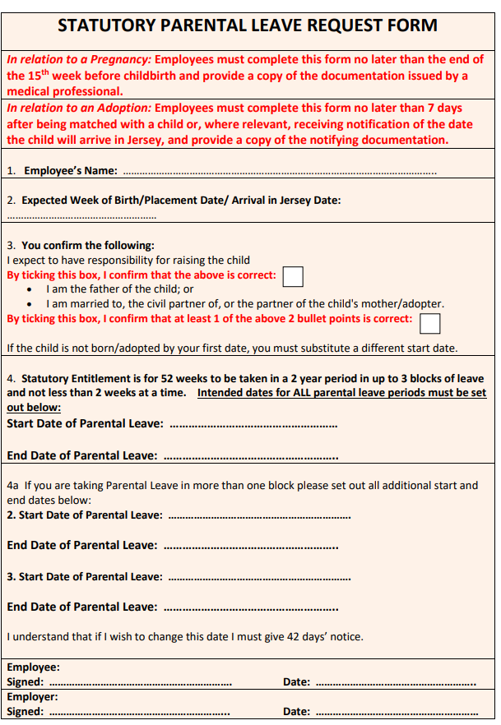
Breastfeeding/Expressing
An employee who is breastfeeding is entitled to request a temporary variation to her terms of employment for the sole purpose of enabling her to breast feed, if the variation relates to:

· The hours during which the employee is required to work;
· The times the employee is required to work;
· The place where the employee is required to work.

When making the request the employee must state:
· The purpose of the variation; and
· what the variation being requested is and the period of time it would be in place for.

The employee should make this request to their manager.
This Temporary change to your terms and conditions will not affect your statutory right to apply for flexible working under the “Flexible Working” policy.

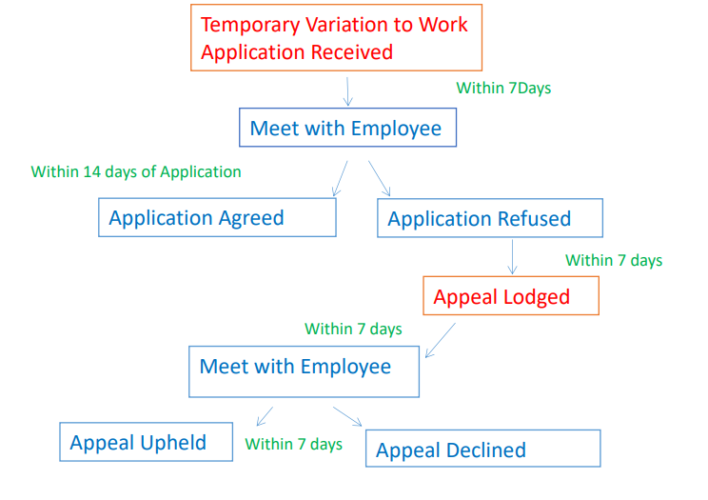

Breastfeeding in the workplace Policy

The employee can request the employer provides facilities for breastfeeding/expressing milk. The employer will discuss with the employee her return to work following a period of parental leave to understand what may be done to assist their return that is both proportionate and reasonable in the provision of facilities, and whether a temporary variation to terms of employment allowing for flexible working or additional paid breaks may be made available.

The employer will take all reasonable steps to provide facilities within the workplace for:

· the extent to which any steps are, or would be if taken effective to provide suitable facilities;
· the extent to which any steps are, or would be if taken practical;
· the cost of any steps which could be taken;
· the financial, administrative and other resources available to the employer.

Breastfeeding mothers are entitled to paid breastfeeding breaks for a period of 52 weeks beginning with the birth of their child. Any breastfeeding breaks agreed after the initial 52 weeks period following the child’s birth will be unpaid. Mothers are entitled to request reasonable temporary variations of terms and conditions of employment for the purpose of breastfeeding and/or expressing milk.

This Temporary change to your terms and conditions will not affect your statutory right to apply for flexible working under the “Flexible Working” policy.

