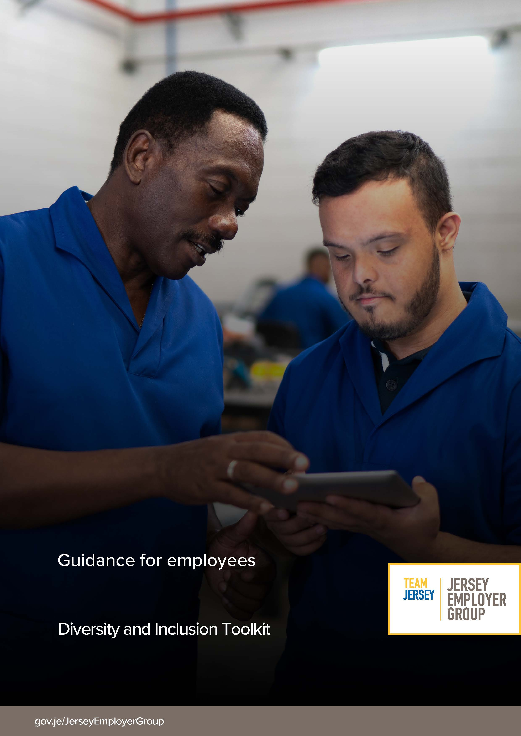

Diversity and Inclusion guidance for employees
What is Diversity and Inclusion?
The Chartered Institute of Personnel & Development define Diversity & Inclusion as follows:

Diversity is about recognising difference. It’s acknowledging the benefit of having a range of perspectives in decision-making and the workforce being representative of the organisation’s customers.
Inclusion is where people’s differences are valued and used to enable everyone to thrive at work. An inclusive working environment is one in which everyone feels that they belong without having to conform, that their contribution matters and they are able to perform to their full potential, no matter their background, identity or circumstances. An inclusive workplace has fair policies and practices in place and enables a diverse range of people to work together effectively.
What does that mean to the workplace?
Promoting & Supporting diversity in the workplace is important, it’s about valuing everyone in the organisation as an individual. It is vital to have an inclusive environment where everyone feels able to participate and achieve their potential.
These areas provide more information on what workplace diversity and inclusion is;
Age Diversity
Age diversity is the ability to accept all different types of ages within a business. Given our aging population, the proportion of older workers in the workforce may be expected to increase. Areas to support age diversity in the workplace are to offer flexible working arrangements, offer phased retirement options and support employee health & wellbeing

Disability
Almost half of the working-age people with disabilities in the UK are unemployed. This represents a huge pool of talent that businesses are potentially missing out on. Look to embed accessibility into every part of the recruitment process, provide myth busting training for employees, adjust working arrangements and be aware of unconscious bias. All these areas of support could increase people with disabilities into the workforce.

Gender Equality
Gender equality is when people of all genders have equal rights, responsibilities and opportunities. Everyone is affected by gender inequality – women, men, trans and gender diverse people, children and families. Steps to ensure that women are paid and treated equally in the workplace, zero tolerance of any form of discrimination and harassment, improvement of workplace flexibility and offerings of inclusive family friendly policies are all areas which enhance gender equality.

Race Inclusion
Every person, regardless of ethnicity or background, should be able to fulfil their potential at work. Organisations who take action to support equal progression and participation in the workplace, across ethnicities, will grow their talent pool. Policies and practices in the workplace are underpinned by principles that actively celebrate and encourage difference.

Religion & Belief
Religion & belief discrimination is when someone is treated differently because of their religion or belief, or lack or religion or belief. To be a genuinely inclusive employer, it is important to understand and be sensitive to employees’ religious and philosophical beliefs. Celebrating religious occasions, having work events which are inclusive for example providing non-alcoholic drinks and a range of food offerings all support religion and belief in the workplace.

Sexual Orientation, Gender Identity & Gender Reassignment
Sexual orientation is the way you identify yourself – through desires, feelings and sexual activity, whether that’s towards people of the same sex or opposite sex from you. Gender identity is rooted less in physical identity and refers to the way you identify with and express yourself in masculine and/or feminine notions of identity. When talking about issues of sexual identity we often use the term LGBTI: lesbian, gay, bisexual, transgender and intersex. But we acknowledge that individuals may define their sexual identity in ways not limited to just these terms – and terms to describe sexual orientation and gender identity vary widely from culture to culture.
An individual’s sexual orientation and gender identity should not affect whether they get a job, benefit from training or get promoted. Organisation policies should be gender-neutral and inclusive.

We all have a part to play
Everyone needs to be committed and play their part. Here are some ideas of what you can do to participate in enhancing the D&I landscape in your organisation:

- Sign up to a network or Employee Resource Group to support an under-represented group & ensure everyone has a voice and feels included.
- Champion an area that you are passionate about to help raise awareness amongst colleagues.
- Share information and resources to educate those around you and improve awareness
- Speak up - provide upward feedback to your leaders to enhance the culture in your organization
- Identify and challenge your own biases
- Call-out/challenge unacceptable comments/behaviours that are not in-line with your organisations’ values
- Look outside your company to external and community activities – get involved and champion and support other external initiatives. Spread the word and encourage your colleagues to attend.

