Press Release

Jersey Architects Week 2nd to 7th October 2006
The Next Big Event

Jersey Architecture Week, which runs from 2nd to 7th October, will be a major Island event focusing on ‘Great Design’. A precursor to Architects Week is the visit to the island of the famous international architect, Quinlan Terry who will be giving an illustrated lecture in the Assembly Room of the Town Hall at 6p.m. on Thursday 21st September entitled ‘Ornamenting Construction or Constructing Ornament?’ The firm of Quinlan and Francis Terry continues the architectural style of the practice which was started by Raymond Erith in 1928 and specializes in high quality traditional building of a classical design.


Often described as Prince Charles’s favourite architect, Quinlan Terry vigorously upholds the ideals of contemporary buildings designed to complement structures in environments whose character is defined by handsome and noble buildings from previous centuries. His visit to Jersey coincides with the publication of his latest book ‘Radical Classicism’ and it is this which he will be talking about.

His lecture is open to members of the public and is certainly not to be missed by anyone with an interest in a modern interpretation of classical architectural styles.

Web: http://www.qftarchitects.net/800index.html

Architecture Week is a joint venture between the Department of Planning and Environment and the Association of Jersey Architects (AJA). It marks a step change in that relationship, one designed to bring the Department and the AJA closer together to maintain not only harmonious relations, but also increased efficiency in the use and implementation of the regulations designed to improve overall standards of design, best summarised by Senator Freddie Cohen, the Minister of Planning and Environment: “successful planning policies come primarily from an emphasis on good design in new buildings”.

This view is enshrined in the strap line for Jersey Architecture Week - ‘Good Design, Better Buildings’.

Mike Waddington, President of the AJA, says “We are delighted with the combined partnership with the Planning and Environment Department and the Minister that has allowed us jointly to develop this week. It is in everyone’s interest to ensure that the design and construction of buildings in Jersey meets the highest standards and we welcome both the Minister’s commitment to this requirement and the developments he is initiating within the Department to achieve it.”

The Minister is very keen to get the public involved in understanding what the term ‘Good Design’ means and the programme, to be published on 25th September includes a dramatic exhibition in the Royal Square

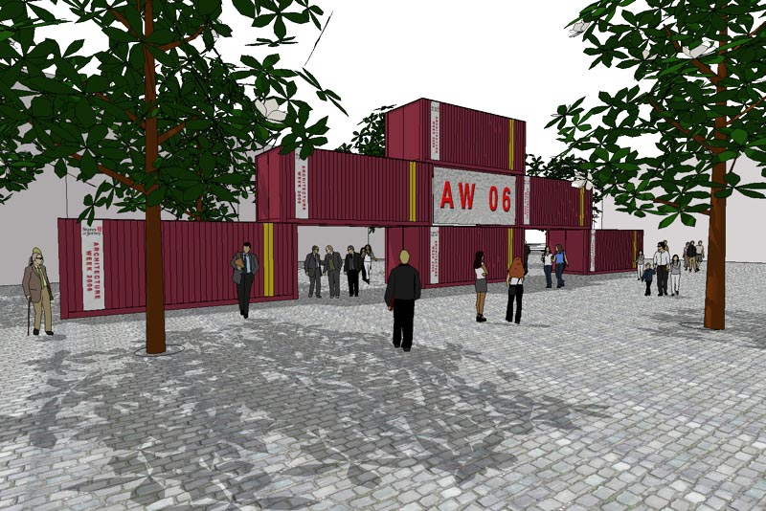

Of particular interest will be a panel, produced by Jersey Heritage showing the 1785 survey of Jersey overlaid onto the latest Digi map, thus allowing people to see how much land has been reclaimed through the ages.

Every evening, at 6pm in the Assembly Room of the Town Hall internationally acclaimed architects will be speaking on various aspects of Good Design These are free and members of the public are welcome. The series starts with Sir Richard MacCormac on 2nd October addressing the issue of ‘What can architecture say?’

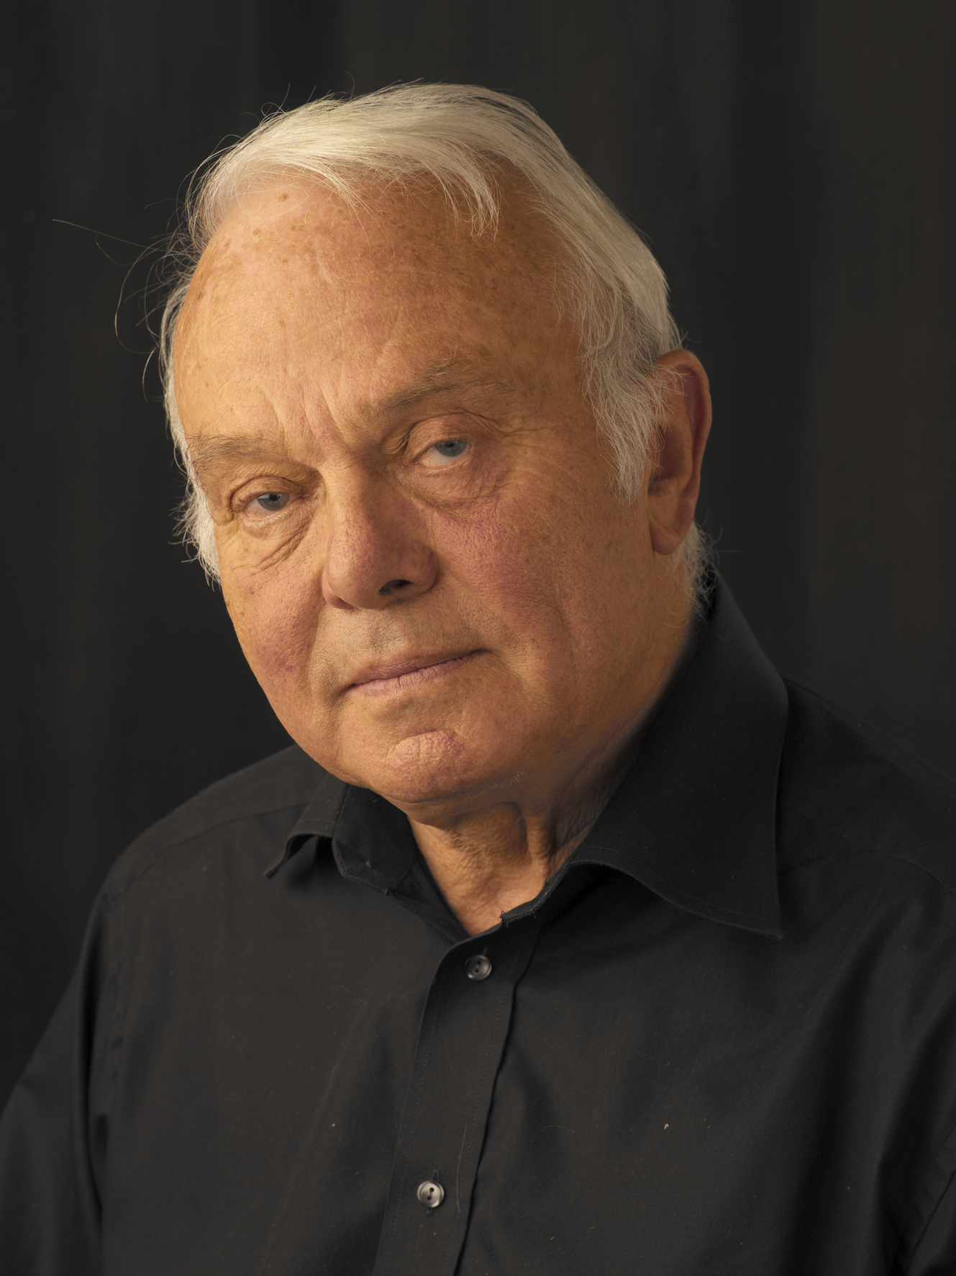
Sir Richard is chairman of MacCormac Jamieson Prichard, which was established in 1972 and incorporated in 2002.
He designed the Ruskin Library at Lancaster University, the Wellcome Wing at the Science Museum and is currently designing the expansion of Cambridge University into West Cambridge the Phoenix Initiative, a regeneration project for Coventry and a new building in Kensington Place, St Helier.

Web: mjp@mjparchitects.com

Sir Richard will be followed on 3rd October by Seán O’Laoire.


Seán joined Murray O’Laoire as Partner in 1979. Previously he was a Lecturer at the School of Architecture, Bolton Street, Dublin. Seán holds a Master’s Degree in Urban Design and has also worked in England, Italy and the USA.

He is the lead architect for the development of the Esplanade Square in St Helier. Web: http://www.murrayolaoire.com

On 4th October the public will be able to find out more about the development of the Waterfront and its linking into the main town when Jim Greaves of Hopkins Architects, the practice that have been given overall design responsibility for the development of this vital area, speaks.
James Greaves has been with the Hopkins Architects for 18 years. He was made a Project Director in 1990 and a Director in 1995. He is a visiting critic at the Queen’s University, Belfast and has taught and lectured widely on the work of the Practice. Previous projects include the Victoria and Albert Museum, Phase Two of the Schlumberger Cambridge Research Centre and the Queen’s Building, Emmanuel College in Cambridge. He has extensive experience of master planning; most recently he has completed the Development Framework for Leicester’s Waterside, on behalf of the Leicester Regeneration Company

Web: http://www.hopkins.co.uk/main.html
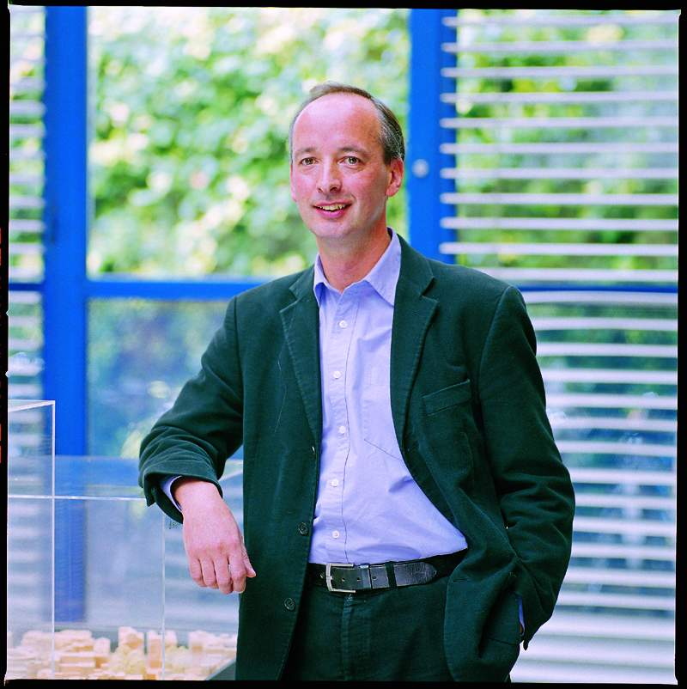

On 5th October Sir Michael Hopkins, Chairman of Hopkins Architects will speak on ‘The Essence of Good Design’, thus summarising the first part of the overall programme.

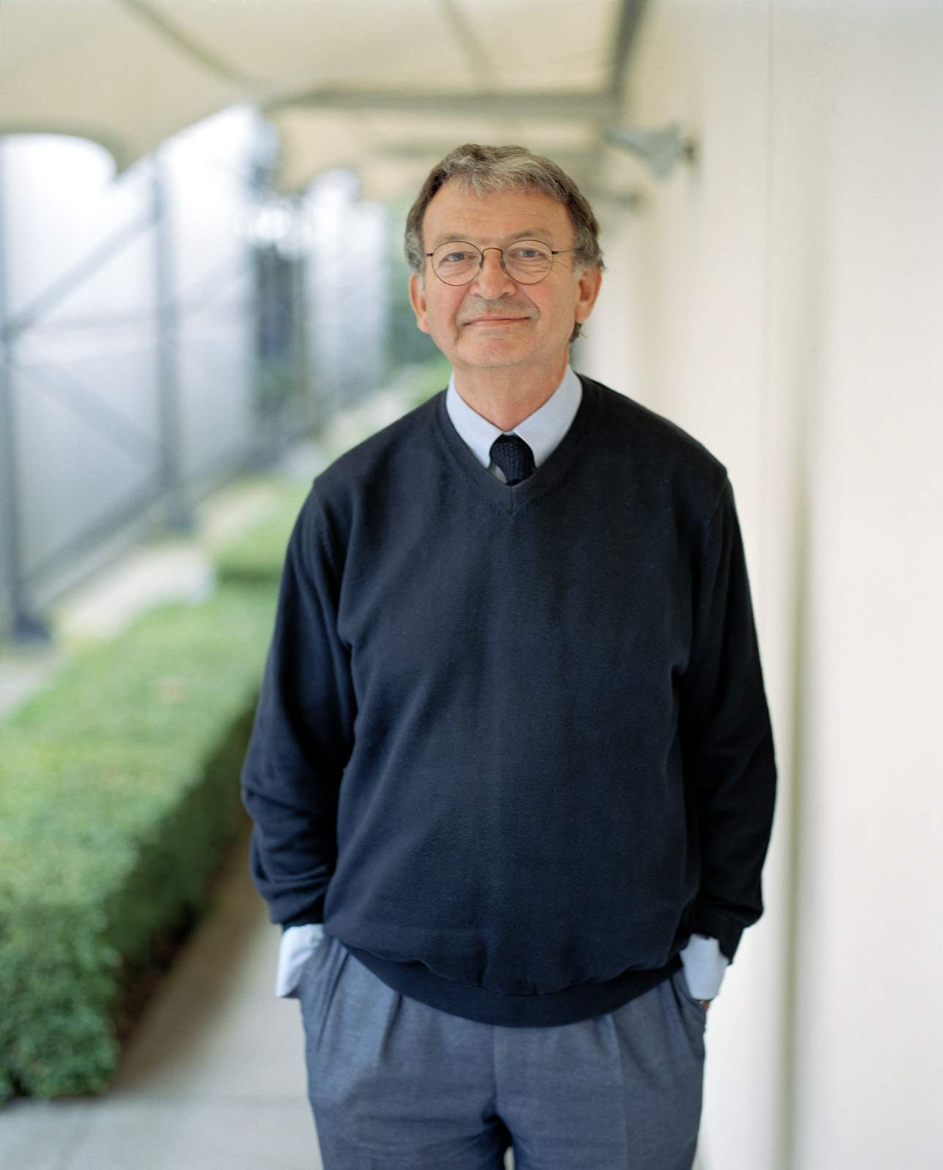
Since 1976 Michael Hopkins and Partners have been leading pioneers in British architecture, producing buildings that have a popular public appeal and are consistently award winning designs. The practice has three partners - the founders and RIBA Gold Medal laureates Michael and Patty Hopkins, and Bill Taylor.

Web: http://www.hopkins.co.uk/main.html

The Jersey Design Awards, at the Pomme d’Or Hotel, on Friday 6th October, organised by the Department of Planning and Environment, celebrates what has been achieved in the past 2 years and will be addressed by Professor Will Alsop, again one of Europe’s leading architects.

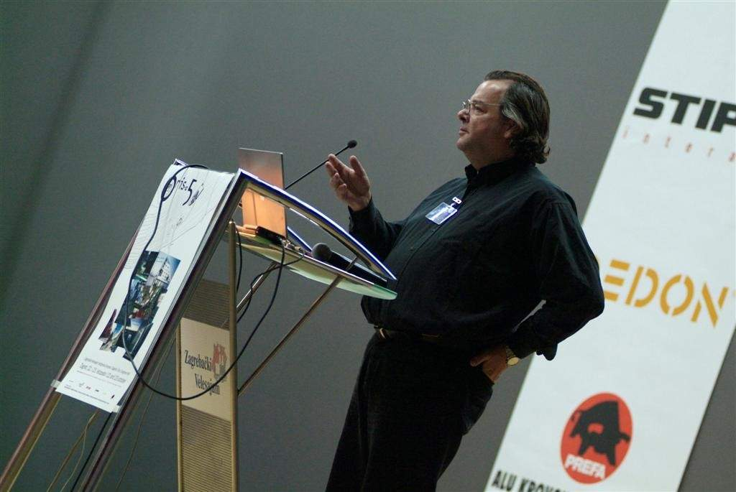
Will Alsop, who designed the La Fregate café in Jersey, follows a parallel path as an artist, feeling that it is a discipline inseparable from architecture. He was a tutor of sculpture at Central St. Martins College of Art & Design, London, for several years, has held many other academic posts, and actively promotes the artistic contribution to the built environment.

Web: http://www.rca.ac.uk/pages/research/will_alsop_3164.html

This event recognises the achievements of Jersey’s architects, is open to the public and starts at 6 p.m. Doors open at 5.30 p.m.

Throughout the week there will be further opportunities for the public to learn more about the background to the Planning Minister’s desire to improve the built environment, a strategy endorsed by the States in its 2006 Strategic Plan. These include a breakfast series, Food 4 Thought, where a prominent Islander will respond to the previous evenings lecture over breakfast at the Pomme d’Or Hotel. These breakfasts, from Tuesday to Friday of Architects Week, cost £10 each or £35 for the series and tickets will be on sale from the States Bookshop and Naish Waddington Architects in St Andrew’s Place.

The Planning and Environment Department is also organizing planning workshops, to take place in the Willow Room, Hill Street, in conjunction with the AJA. These will last 15 minutes; they take place at lunchtime from Tuesday to Friday of Architects Week with an additional workshop on the Saturday morning and can be booked in advance at the States Bookshop. In addition there will be free lunchtime lectures in the Old Library and free tours of buildings and features in St Helier, led by prominent historians and local architects, where you can find out more about our local architecture and the plans for Jersey’s development.

The JEP is sponsoring a unique competition for schools, where individuals and classes can enter a bridge that spans 1 metre and can hold a weight of 1kg. The only other stipulation is that is constructed only from old copies of the JEP, using glue and the paper. Judging is on Thursday 4th October with the final at 5 pm on Friday 6th October.

In the words of the Minister, Freddie Cohen, “Architecture Week is a very exciting opportunity for local architects to celebrate their achievements and for us all to draw on the experience of the great international architects who will be speaking in Jersey during the week. I hope this will mark a turning point which will encourage architects, their clients and the Planning Department to work together to achieve uncompromised Good Design and through that to deliver buildings that are an inspiration to Islanders and I look forward to islanders joining-in during the week. It is a real opportunity to learn about the issues that will be developing our island in the coming years. There really is something for everyone!”

And finally, it is true to say that none of this would have been possible without the support of our sponsors:

- The Planning and Environment Department
- Pentagon Builders Merchant
- Island Development Limited (IDL)
- Dandara
- CIT Estates
- Huelin Renouf
- Regal Construction (Jersey) Limited

Annex A
Jersey Architecture Week – 2nd to 7th October 2006
Programme

(Version 8 as at 290906)

Serial | Date | Time | Event | Speaker | Location
(a) | (b) | (c) | (d) | (e) | (f)
 | Monday 2nd October | Official Opening  1300 hours | Opening Ceremony – Mike Waddington, President the AJA | Sir Richard MacCormac  CBE | Royal Square
 |  | 1800 to 1930 hours | What Can Architecture Say | Sir Richard MacCormac CBE, MA, PPRIBA, RA | Town Hall
 | Tuesday 3rd October | O730 to 0900 hours | Food 4 Thought – Good Design in Jersey | Martin Bralsford | Pomme d’Or Hotel
 |  | 1300 to 1400 hours | Energy, innovation and sustainability in the built environment - how? | Deputy Rob Duhamel – Chairman of the Scrutiny Environment Panel | Old Library
 |  | 1300 to 1400 hours | Planning and Design workshop |  | Willow Room, 23 Hill Street
 |  | 1300 to 1400 hours | AJA Building Tour | Derek Mason | Morier House, Halkett Place
 |  | 1400 to 1600 hours | How Well do You Know Your Town? | Frank Falle | Liberation Square

(a) | (b) | (c) | (d) | (e) | (f)
 |  | 1800 to 1930 hours | Developing Esplanade Square | Sean O’Laoire  B ARCH, M ARCH in UD, FRIAI | The Town Hall
 | Wednesday 4th October | 0730 to 0900 hours | Food 4 Thought 3 – An Alternative View of the development of St Helier, including Esplanade Square | Mike Liston | Pomme d’Or Hotel
 |  | 1300 to 1400 hours | ‘My Town’ – A personal view on the good and the bad developments in St Helier and a vision of the future, particularly for those living in town. | Connétable Simon Crowcroft | Old Library
 |  | 1300 to 1400 hours | Planning and Design workshop |  | Willow Room, 23 Hill Street
 |  | 1300 to 1400 hours | AJA Building Tour | Paul Harding | Le Coie Estate – meet at Springfield Stadium entrance
 |  | 1400 to 1530 hours | Architecture Tour – The Waterfront As You Do Not Know It | Derek Mason | Liberation Square
 |  | 1800 to 1930 hours | The Jersey Waterfront – In St Helier | Jim Greaves | Town Hall

(a) | (b) | (c) | (d) | (e) | (f)
 | Thursday 5th October | 0730 to 0900 hours | Food 4 Thought 3 – An Alternative View of the Waterfront | Advocate Chris Schofield | Pomme d’Or Hotel
 |  | 1300 to 1400 hours | Re-thinking land uses | Paul Nichols – Chief Executive of the Ministry of Planning and Environment | Old Library
 |  | 1300 to 1400 hours | Planning and Design workshop |  | Willow Room, 23 Hill Street
 |  | 1300 to 1400 hours | AJA Building Tour | Ian McDonald | The Island site, Esplanade
 |  | 1400 to 1530 hours | Architecture Tour: Good design | Stuart Fell | Royal Square
 |  | 1600 to 1700 hours | Short listing of Schools Bridge Building Competition | George de Sousa  Chris McCarthy  Anthony Lewis | Town Hall
 |  | 1800 to 1930 hours | The Essence of ‘Good’ design | Sir Michael Hopkins | Town Hall

(a) | (b) | (c) | (d) | (e) | (f)
 | Friday 6th October | 0730 to 0900 hours | Food 4 Thought 4 – Engineering Good Design | Chris McCarthy | Pomme d’Or Hotel
 |  | 1300 to 1400 hours | Housing for the 21st Century | Deputy Sean Power – Environment Scrutiny Panel | Old Library
 |  | 1300 to 1400 hours | AJA Building Tour | Jim Naish | Berkshire Court, La Motte Street
 |  | 1300 to 1400 hours | Planning and Design workshop |  | Willow Room, 23 Hill Street
 |  | 1400 to 1530 hours | Architecture Tour – St Helier regeneration | Simon Crowcroft, Connétable of St Helier (TBC) | The Town Hall
 |  | 1700 to 1730 hours | Judging of Schools Bridge Building Competition | George de Sousa  Will Alsop  Chris McCarthy  Anthony Lewis | Town Hall
 |  | 1800 to 2030 hours | The Jersey Design Awards – ‘Good Taste’ in Architecture | Prof. Will Alsop OBE RA | Pomme d’Or Hotel
 | Saturday 7th October | 1030 to 1600 hours | Architecture Week Exhibition
 |  | 1100 to 1400 hours | Planning and Design workshop |  | Willow Room, 23 Hill Street
 |  | 1400 hours | Architecture Tour – The Waterfront As You Do Not Know It | Derek Mason | Liberation Square

