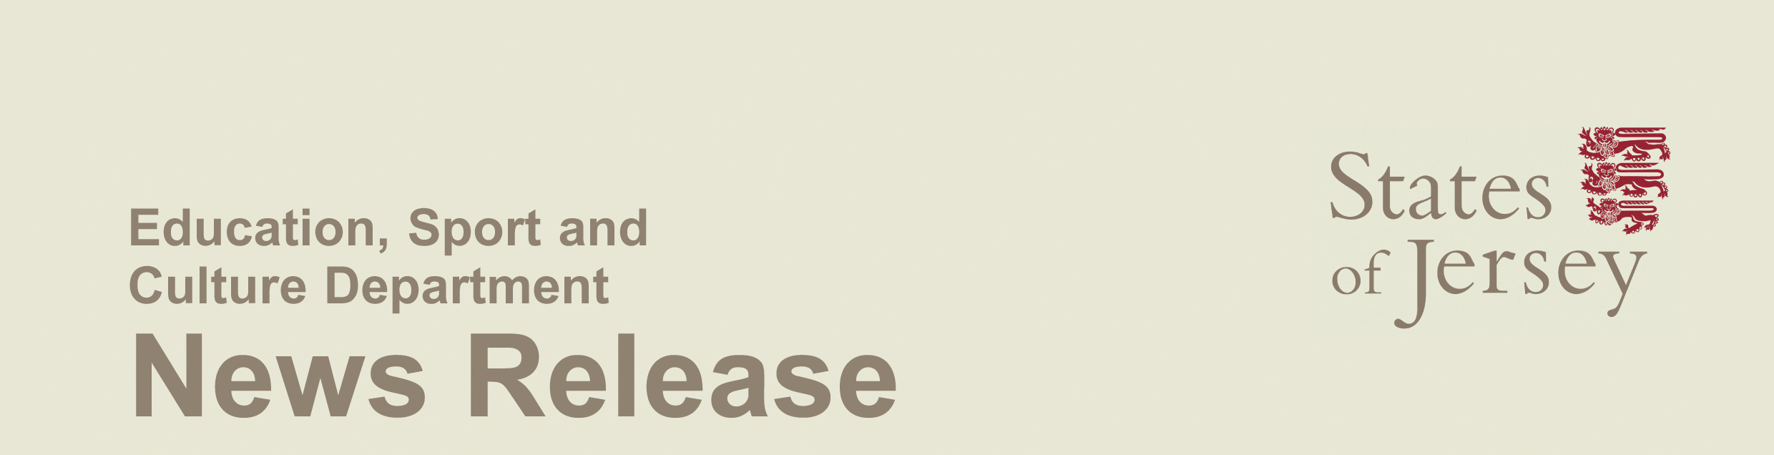

29 July, 2008

Tours of States Chamber and Royal Court

The States and the Royal Court are open to the public on Saturday mornings during the summer as part of a conducted tour offered by Blue Badge guide Paul Nicolle with support from Education, Sport and Culture.

Mr Nicolle offers an insight into Jersey’s history and culture on a tour which takes visitors into the States Chamber, the Royal Court and the Town Church. He explains the influence of Jersey’s Norman heritage and the implications of the events of 1204 which led to the emergence of the Royal Court and later the States of Jersey.

The tour gives the opportunity not only to visit the Royal Court building and the States Chamber but also to see the Royal Mace given to the Island in 1663 and paintings in the Royal Court and its anterooms, including the portrait of Governor Conway commissioned by the States from Thomas Gainsborough in 1780.

Deputy Carolyn Labey, Assistant Minister for Culture, welcomed the tours which she said made a further positive contribution to encouraging a sense of identity in the Island, one of the aims of the States Cultural Strategy.

“ESC has done a considerable amount of work with the States Greffe on opening up the States Chamber to primary schools. A message which emerged from the recent cultural conference was the extent to which many adults would also value the chance to learn about the history of our government and our historical relationship with the UK and France.

“I’m delighted that we have been able to work with Mr Nicolle to offer an opportunity for the public to learn about this important aspect of our culture and to see pictures and artefacts which would ordinarily be difficult to access,” she said.

There is a £5 charge for the tour which runs from 10 am to 12.30 pm, and numbers are restricted to 25 on a ‘first-come first served’ basis. Participants meet by the statue of George II in the Royal Square and the tours run each Saturday until 20 September.

Notes to Editors:
- For further information, please contact

Paul Nicolle
Tel.: 872665

Deputy Carolyn Labey
Tel.: 852488
Mobile 07797713140
email c.labey@gov.je

