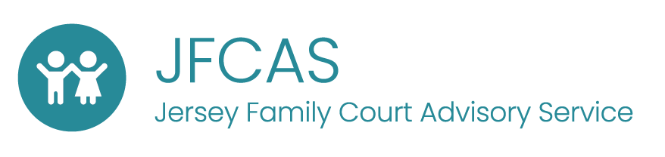

Dear xxxxx

My name is Eleanor. I work for a place called JFCAS (the Jersey Family Court Advisory Service).

Sometimes, when people are worried about the safety of a child, the Children’s Service might ask the family court to make decisions about helping that child to be safe and properly looked after.

It is my job to come and meet you and find out a bit more about you, to help the Court understand what you want and need.

I am going to arrange a time to come and meet you soon and I will explain all about what I do then. I am looking forward to meeting you.

From

Eleanor

