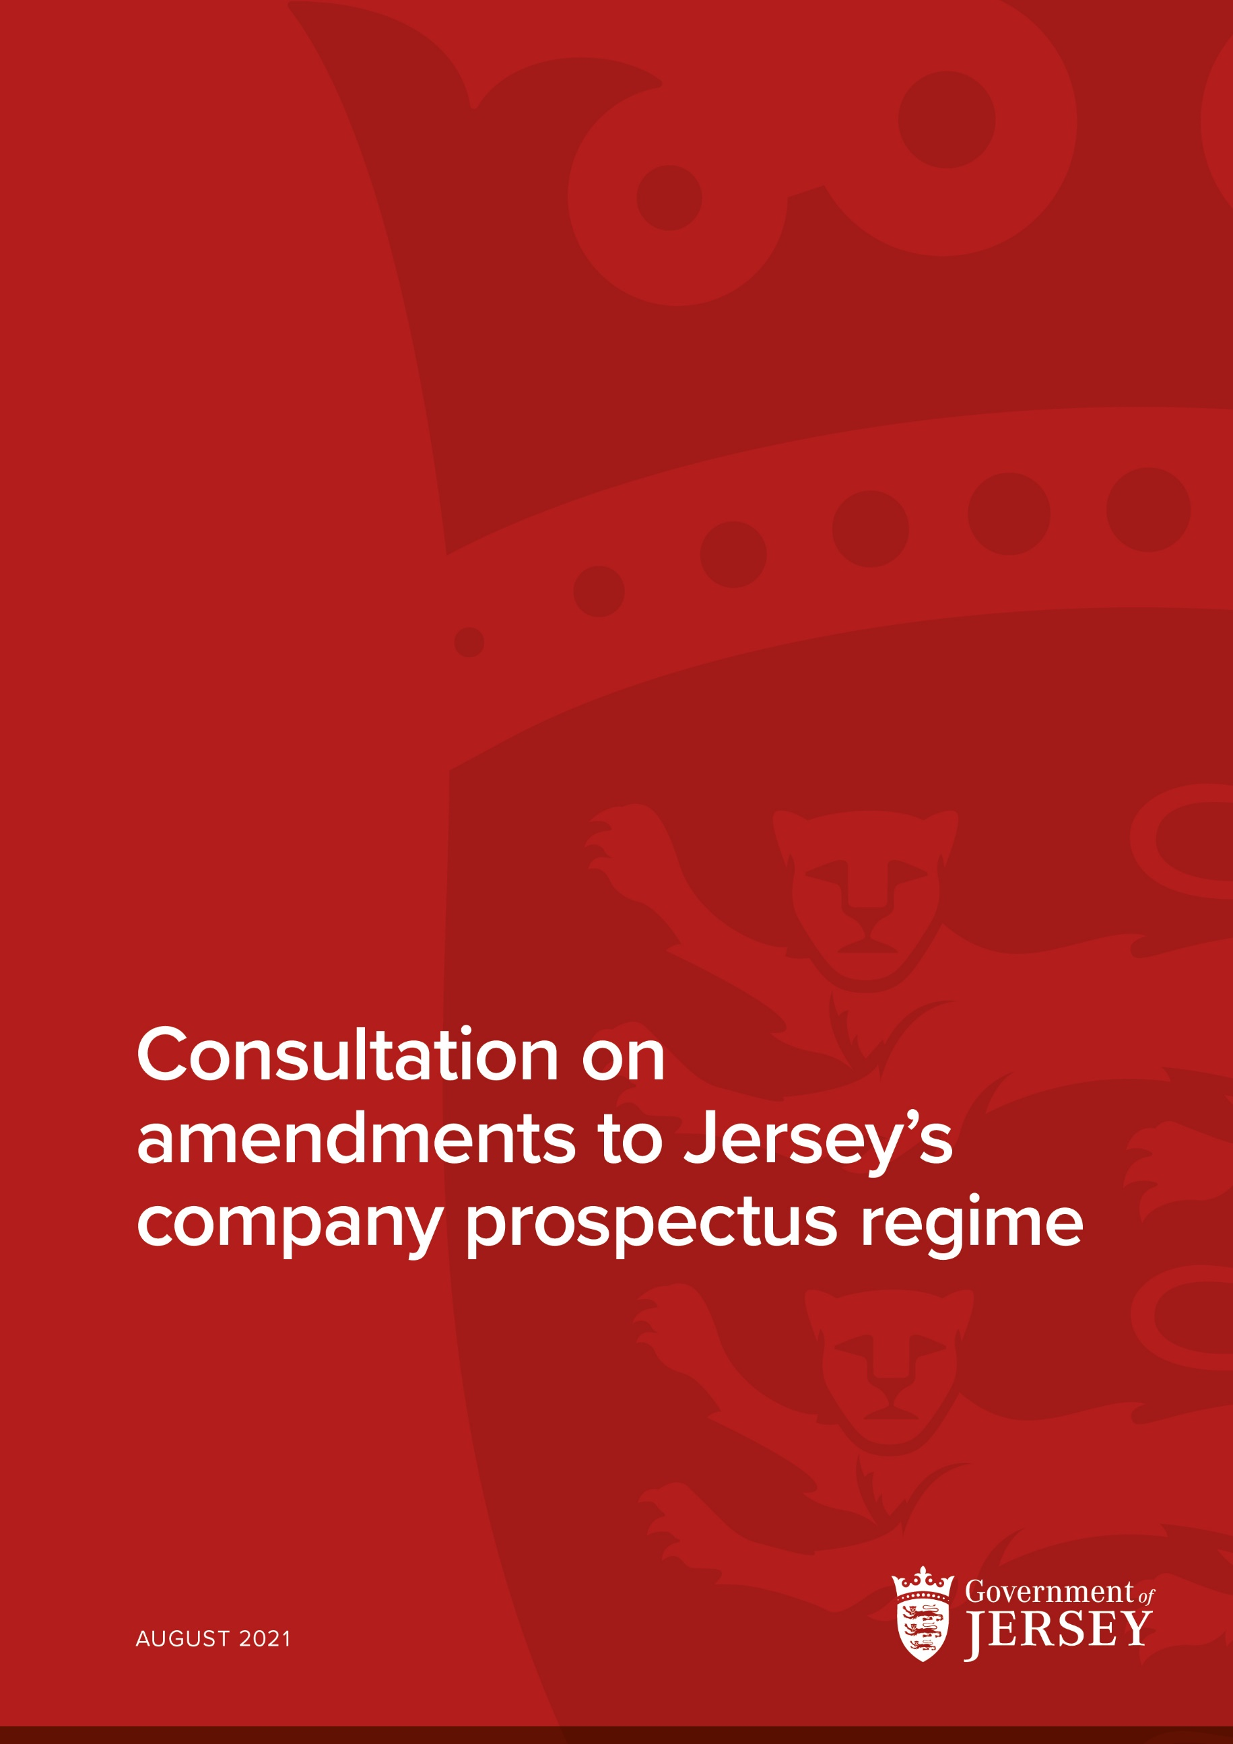

Consultation on amendments to Jersey’s company prospectus regime
Summary
The Government of Jersey is considering amendments to the definition of “prospectus” in the Companies (Jersey) Law 1991 (the “Companies Law”). An amendment made to the Companies Law in 2014 allowed the definition of “prospectus” to be amended by way of Ministerial Order.
The Government of Jersey has been working closely with Jersey Finance and the Jersey Financial Services Commission (the “Commission”) to identify ways in which a modern and more flexible definition of “prospectus” could sit within Jersey’s respected regulatory framework and continue to offer appropriate levels of consumer protection.
This consultation seeks views on proposals to amend the definition of “prospectus”.
Date published: 10 August 2021
Closing date: 7 September 2021
Supporting documents attached: Draft Companies (Amendment of Law) (No.2) (Jersey) Order 202-
How we will use your information

The information you provide will be processed in compliance with the Data Protection (Jersey) Law 2018 for the purposes of this consultation. For more information, please read our privacy notice at the end of this document.

The Government of Jersey may quote or publish responses to this consultation including (send to other interested parties on request, send to the Scrutiny Office, quote in a published report, report in the media, published on www.gov.je, list on a consultation summary etc.) but will not publish the names and addresses of individuals without consent. Confidential responses will still be included in any summary of statistical information received and views expressed. Under the Freedom of Information (Jersey) Law 2011, information submitted to this consultation may be released if a Freedom of Information request requires it, but no personal data may be released.

Do you give permission for your comments to be quoted?

- No ☐
- Yes, anonymously ☐
- Yes, attributed ☐

Name to attribute comments to:

Organisation to attribute comments to, if applicable:

Ways to respond

In writing to:

Helen De La Cour
Associate Director | Financial Services | Department for the Economy | Chief Executive’s Office
Email: H.DeLaCour@gov.je

Alternatively, Jersey Finance will be collating an industry response and these responses should be sent to:

Lisa Springate
Head of Legal and Technical | Jersey Finance Limited
Email: lisa.springate@jerseyfinance.je
INTRODUCTION
- This Consultation Paper seeks views on proposed amendments to the definition of “prospectus” contained in Article 1 Companies Law.

- In 2012, the Government of Jersey consulted on amendments to the Companies Law to strengthen the competitiveness and standing of the Jersey company. As a result of those amendments, a provision was inserted into the Companies Law by the Companies (Amendment No. 11) (Jersey) Law 2014 (the ”Amendment Law”) to permit the definition of “prospectus” to be amended by Ministerial Order. It was expressed at the time that further consultation and engagement would be undertaken prior to the implementation of any change to the definition.

- The Government of Jersey, the Commission and a Jersey Finance working group comprised of representatives from the local financial services industry has worked to identify amendments to the definition of “prospectus” which would modernise Jersey’s prospectus regime and align it with provisions in the EU and UK, while maintaining adequate levels of consumer protection. This has involved significant investigation into the regimes of other jurisdictions and protections in place.

- Presently, the registrar’s consent is required under the Companies (General Provisions) (Jersey) Order 2002 (the “General Provisions Order”) where an offer document is circulated to more than 50 persons. This can be both costly and administratively burdensome.

- Both the UK, through the Financial Services and Markets Act 2000 and the EU through Regulation (EU) 2017/1129 (the “Prospectus Regulation”) exempt certain types of offers to the public from the requirement to publish a prospectus.

- As a result of the work with the Jersey Finance working group, a number of exemptions are proposed to the definition whereby should the criteria be met, it will not be necessary to prepare a prospectus and obtain the registrar’s consent. These exemptions are considered in more detail below and can be seen in the Draft Companies (Amendment of Law) (Jersey) Order 202- (the “Draft Order”). Government would be grateful for views generally and in response to the questions posed.

EXEMPTION ONE: PROFESSIONAL OR QUALIFIED INVESTORS
- It is proposed to bring into scope an exemption for professional and qualified investors. Both the UK and the EU regimes exempt from the obligation to publish a prospectus offers of securities that are made to qualified investors (Regulation 7 of the Financial Services and Markets Act 2000 (Prospectus) Regulations 2019 and Article 1(4) Prospectus Regulation).

- “Qualified investors” are defined in the Prospectus Regulation by reference to points (1) – (4) of Section I of Annex II EU Directive 2014/65/EU (MiFID II) and persons or entities who are, on request, treated as professional in accordance with Section II of that Annex. This category of persons is considered to have sufficient knowledge, experience and expertise to properly understand and assess the risks involved with the investment.

- In addition, it is proposed that a definition of “professional investor” is also included. This is intended to align with existing definitions (the Financial Services (Investment Business (Special Purpose Investment Business – Exemption)) (Jersey) Order 2001 and the Financial Services (Investment Business (Restricted Investment Business – Exemption)) (Jersey) Order 2001). This additional definition reflects the need to capture non-EU deals.
Question one: Do you agree with the proposal to exempt offers to professional and qualified investors from the need to prepare a prospectus? Please provide any comments.

EXEMPTION TWO: RESTRICTED CIRCLE OF INVESTORS
- Article 1(4)(b) of the EU Directive also exempts from the requirement to publish a prospectus offers of securities addressed to fewer than 150 natural or legal persons per Member State, other than qualified investors.

- Currently, the definition of prospectus excludes an invitation to a restricted circle of persons, where such an invitation is made to fewer than 50 persons in Jersey or elsewhere.

- Careful consideration has been given as to whether this provision should be aligned to the UK and EU positions and increased to 150 persons. As the draft provision specifically excludes qualified and professional investors from this 50-person limit, this provision potentially allows for retail investors. In the absence of a prospectus, it is possible that retail investors will not have the requisite knowledge and resources to make an informed decision regarding an investment.

- Furthermore, a company that circulates a prospectus is deemed a public company. This may provide additional protections such as a requirement for accounts to be audited. The requirement to have audited accounts would also fall away if the company was exempted from the obligation to produce a prospectus.

- Government has worked closely with the Jersey Finance working group to ascertain whether there are any protections in place in other jurisdictions to mitigate against any potential risk to retail investors, should the threshold be raised. Government is advised that a Jersey company issuing securities in the UK and anyone promoting such securities in the UK would be subject to the same restrictions that apply to a UK company issuing securities in the UK and its promotor. Any offers or promotions in the UK will be subject to the Prospectus Regulation and the financial promotions regime under the Financial Services and Markets Act 2000.

- In balancing the need to extend the restricted circle of persons to more than 50, Government has given consideration to the protections available under Jersey legislation for Jersey based investors. Although anecdotal evidence suggests that few invitations are circulated with the intention to raise capital in Jersey, Government is mindful that the same levels of protection do not exist and the risk this presents to retail investors.

- Based on the protections available in addition to the ability for jurisdictions to make provision for protection when a prospectus is circulated in that jurisdiction, Government is minded to increase the threshold for offers circulated outside of Jersey to 150 persons.

- For offers circulated within Jersey there remains some concern of exposure to retail investors. With that in mind, Government proposes to maintain the limit of 50 persons to whom an invitation circulated in Jersey is addressed.

- Government considers that this two-tiered approach to local and international invitations strikes an appropriate balance.
Question two: Do you agree with the intention to raise the limit on international invitations to 150 persons while maintaining a limit of 50 persons locally, excluding in both instances professional and sophisticated investors? Please provide any comments.

EXEMPTIONS THREE AND FOUR: MINIMUM CONSIDERATION AND DENOMINATION
- A minimum denomination and minimum subscription exemption are also being considered. The rationale for the exemption is that those investing sums of this amount are sufficiently large that they would not run the risk of capturing retail or potentially vulnerable investors.

- The UK and EU have adopted a sum of EUR 100 000 for both the minimum consideration and the minimum denomination.

- Consideration was given to whether it would be appropriate to adopt a lower figure, however, Government is mindful that there is risk of capturing retail or unsophisticated investors should a lower figure be adopted. Government considers that the threshold adopted by the UK and EU strikes an appropriate balance.

- While it may seem unusual to adopt another currency as a reference point, to do so would align Jersey with the UK and EU position. It would also ensure a consistent and familiar approach to intermediaries introducing work to Jersey. Other pieces of legislation, for example, the Money Laundering (Jersey) Order 2008, refer to Euros rather than GBP.
Question three: Do you consider it helpful to align the monetary values with those adopted by the EU and UK? Please provide any comments.
EXEMPTION FIVE: SCRIP DIVIDENDS
- Companies may sometimes offer scrip dividends, allowing existing shareholders to opt for additional shares as an alternative to a cash dividend.

- Scrip dividend offers may sometimes fall within the definition of prospectus despite the offer being made to existing investors with knowledge and experience of the company. These are not new investors in a company and therefore it is arguable that the need for a full prospectus setting out the investor warnings and disclosures is not required.

- It is therefore proposed that offers of distributions made to existing members in the form of shares shall be exempt from the requirements of a prospectus.
Question four: Do you agree that it is appropriate to exempt the offers of scrip dividends from the need to prepare a prospectus? Please provide any comments.
EXCEMPTION SIX: REPLICATION OF THE COMPANIES (GENERAL PROVISIONS) (JERSEY) ORDER 2002 EXEMPTION
- The final proposal is to replicate the existing exemption set out in Article 3(c) of the “General Provisions Order.

- This exemption applies to directors and former directors, employees and former employees and family members of those persons. Reference to this Article of the General Provisions Order seeks to make clear all the exemptions in one place. It does not intend to amend the existing provision.
Question five: Do you agree it is helpful to include all relevant exemptions in one place?

NEXT STEPS AND CONCLUSION
- The Government of Jersey welcomes feedback on the questions posed in this Consultation and on the Draft Order generally.

- Subject to feedback received to this Consultation Paper, the Government intends to make the relevant Order during the second half of 2021. The Order will come into force seven days after it is made.

SUMMARY OF QUESTIONS
Question one | Do you agree with the proposal to exempt offers to professional and qualified investors from the need to prepare a prospectus? Please provide any comments.
Question two | Do you agree with the intention to raise the limit on international invitations to 150 persons while maintaining a limit of 50 persons locally? Please provide any comments.
Question three | Do you consider it helpful to align the monetary values with those adopted by the EU and UK? Please provide any comments.
Question four | Do you agree that it is appropriate to exempt the offers of scrip dividends from the need to prepare a prospectus? Please provide any comments.
Question five | Do you agree it is helpful to include all relevant exemptions in one place?

Data Protection (Jersey) Law 2018 Privacy Notice
How will we use the information about you?
We will use the information you provide in a manner that conforms to the Data Protection (Jersey) Law 2018.
We will endeavour to keep your information accurate and up to date and not keep it for longer than is necessary. In some instances the law sets the length of time information has to be kept. Please ask to see our retention schedules for more detail about how long we retain your information.
We may not be able to provide you with a service unless we have enough information or your permission to use that information.
We will not pass any personal data on to anyone outside of the States of Jersey, other than those who either process information on our behalf, or because of a legal requirement, and we will only do so, where possible, after we have ensured that sufficient steps have been taken by the recipient to protect your personal data.
We will not disclose any information that you provide ‘in confidence’, to anyone else without your permission, except in the few situations where disclosure is required by law, or where we have good reason to believe that failing to share the information would put someone else at risk. You will be told about this unless there are exceptional reasons not to do so.
We do not process your information overseas using web services that are hosted outside the European Economic Area.
Data Sharing
We may need to pass your information to other States of Jersey (SOJ) departments or organisations to fulfil your request for a service. These departments and organisations are obliged to keep your details securely, and only use your information for the purposes of processing your service request.
We may disclose information to other departments where it is necessary, either to comply with a legal obligation, or where permitted under other legislation. Examples of this include, but are not limited to: where the disclosure is necessary for the purposes of the prevention and/or detection of crime; for the purposes of meeting statutory obligations; or to prevent risk of harm to an individual, etc.
At no time will your information be passed to organisations for marketing or sales purposes or for any commercial use without your prior express consent.
Your rights
You can ask us to stop processing your information
You have the right to request that we stop processing your personal data in relation to any of our services. However, this may cause delays or prevent us delivering a service to you. Where possible we will seek to comply with your request but we may be required to hold or process information to comply with a legal requirement.
You can withdraw your consent to the processing of your information
In the few instances when you have given your consent to process your information, you have the right to withdraw your consent to the further processing of your personal data. However, this may cause delays or prevent us delivering a service to you. We will always seek to comply with your request but we may be required to hold or process your information in order to comply with a legal requirement.
You can ask us to correct or amend your information
You have the right to challenge the accuracy of the information we hold about you and request that it is corrected where necessary. We will seek to ensure that corrections are made not only to the data that we hold but also any data held by other organisations/parties that process data on our behalf.
You request that the processing of your personal data is restricted
You have the right to request that we restrict the processing of your personal information. You can exercise this right in instances where you believe the information being processed in inaccurate, out of date, or there are no legitimate grounds for the processing. We will always seek to comply with your request but we may be required to continue to process your information in order to comply with a legal requirement.
You can ask us for a copy of the information we hold about you
You are legally entitled to request a list of, or a copy of any information that we hold about you. However where our records are not held in a way that easily identifies you, for example a land registry, we may not be able to provide you with a copy of your information, although we will do everything we can to comply with your request.
You can ask us:
- to stop processing your information
- to correct or amend your information
- for a copy of the information we hold about you.
You can also:
- request that the processing of your personal data is restricted
- withdraw your consent to the processing of your information.
You can complain to us about the way your information is being used by contacting us at dataprotection2018@gov.je alternatively you can complain to the Information Commissioner by emailing enquiries@dataci.org.

